Jared Reichardt

Database Project Assignment 6: Queries and Results

Create 20 unique queries in SQL and provide screenshots of the results.

10 or more queries should be **complex** (using JOIN, ORDER BY, subqueries, AND, HAVING, etc.)

Please upload a word doc to Moodle and GitHub. Discuss your assignment on Flipgrid.

Example (complex):

We will be offering a 20% off sale for the Texas locations. We need the email addresses, first and last names, and customer IDs, and the state they live in so we can send the customers that go to the Texas locations the promotion via email.

select CustomerID, FirstName, LastName, c.State, c.Email, l.LocationID

From Customer as c

Join Location as l

on c.LocationID=l.LocationID

where c.State = 'TX';

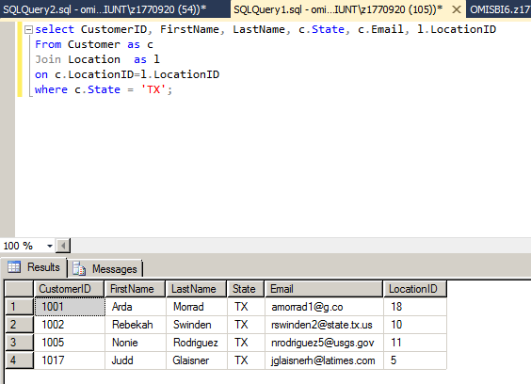

**SQL statements with results**

SELECT cust_fname, cust_lname, c.owner_id, pet_name

FROM customer_pet_owner as c

JOIN pets as p on c.owner_id = p.owner_id

WHERE c.owner_id = 2

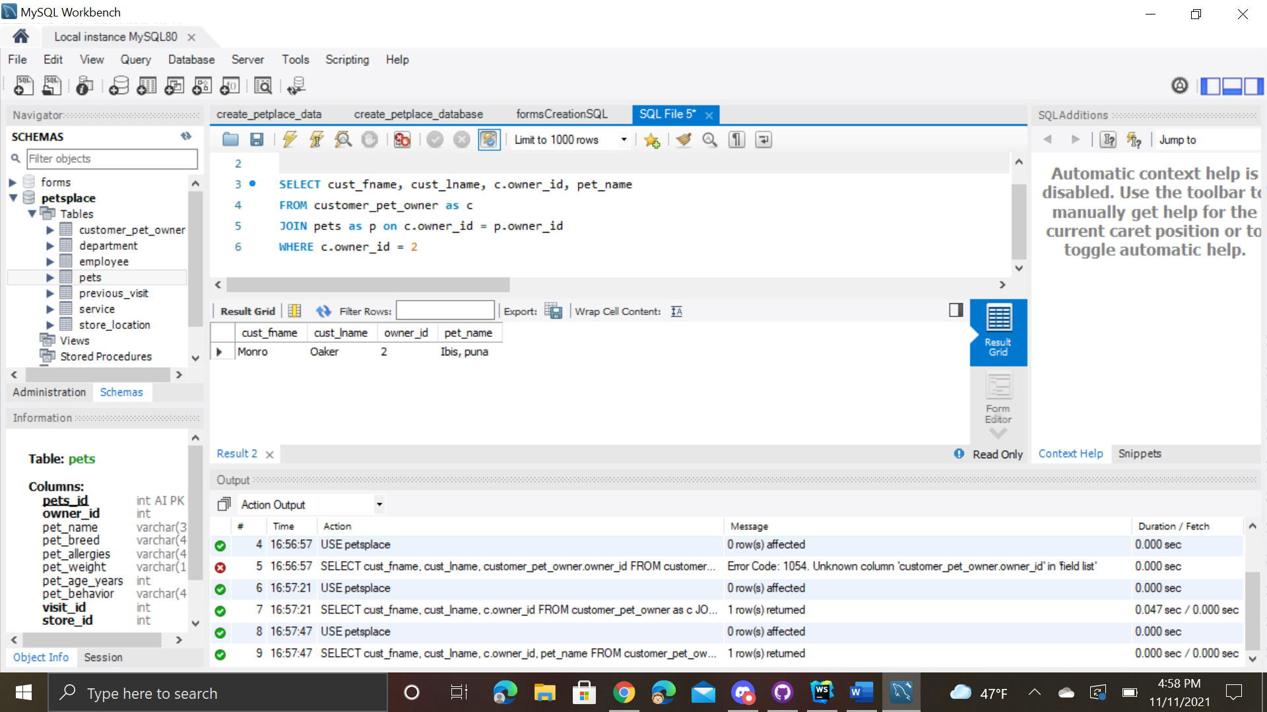



SELECT * FROM store_location WHERE store_id = 2

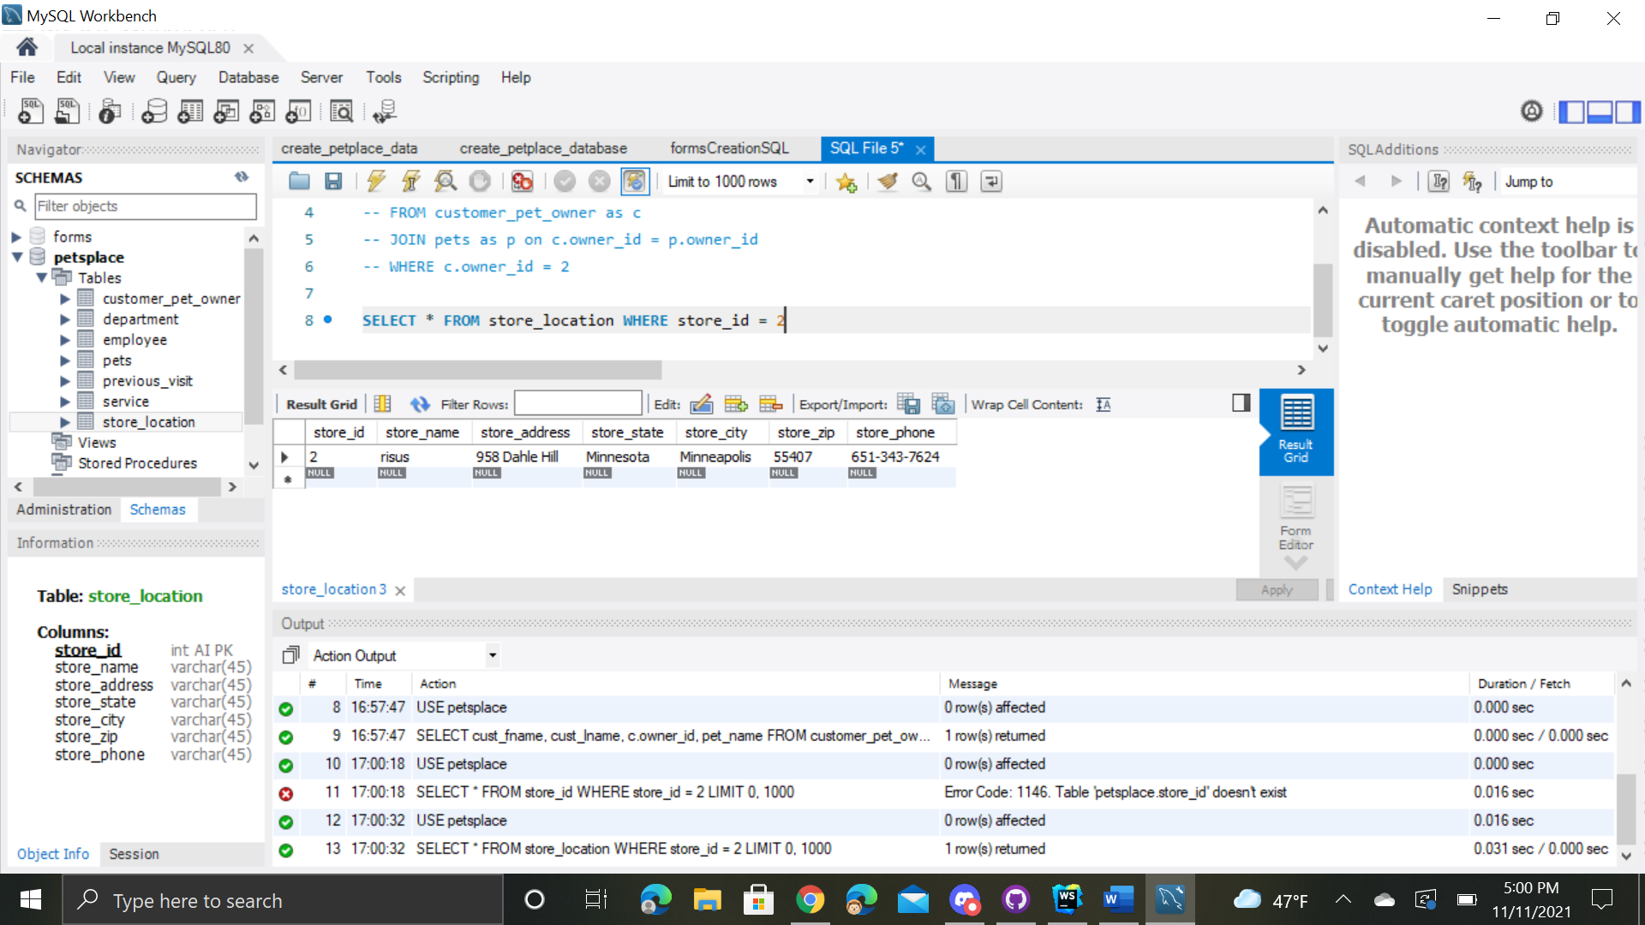



SELECT dept_name, dept_email FROM store_location as s

JOIN department as d on d.store_id = s.store_id

WHERE d.store_id = 1

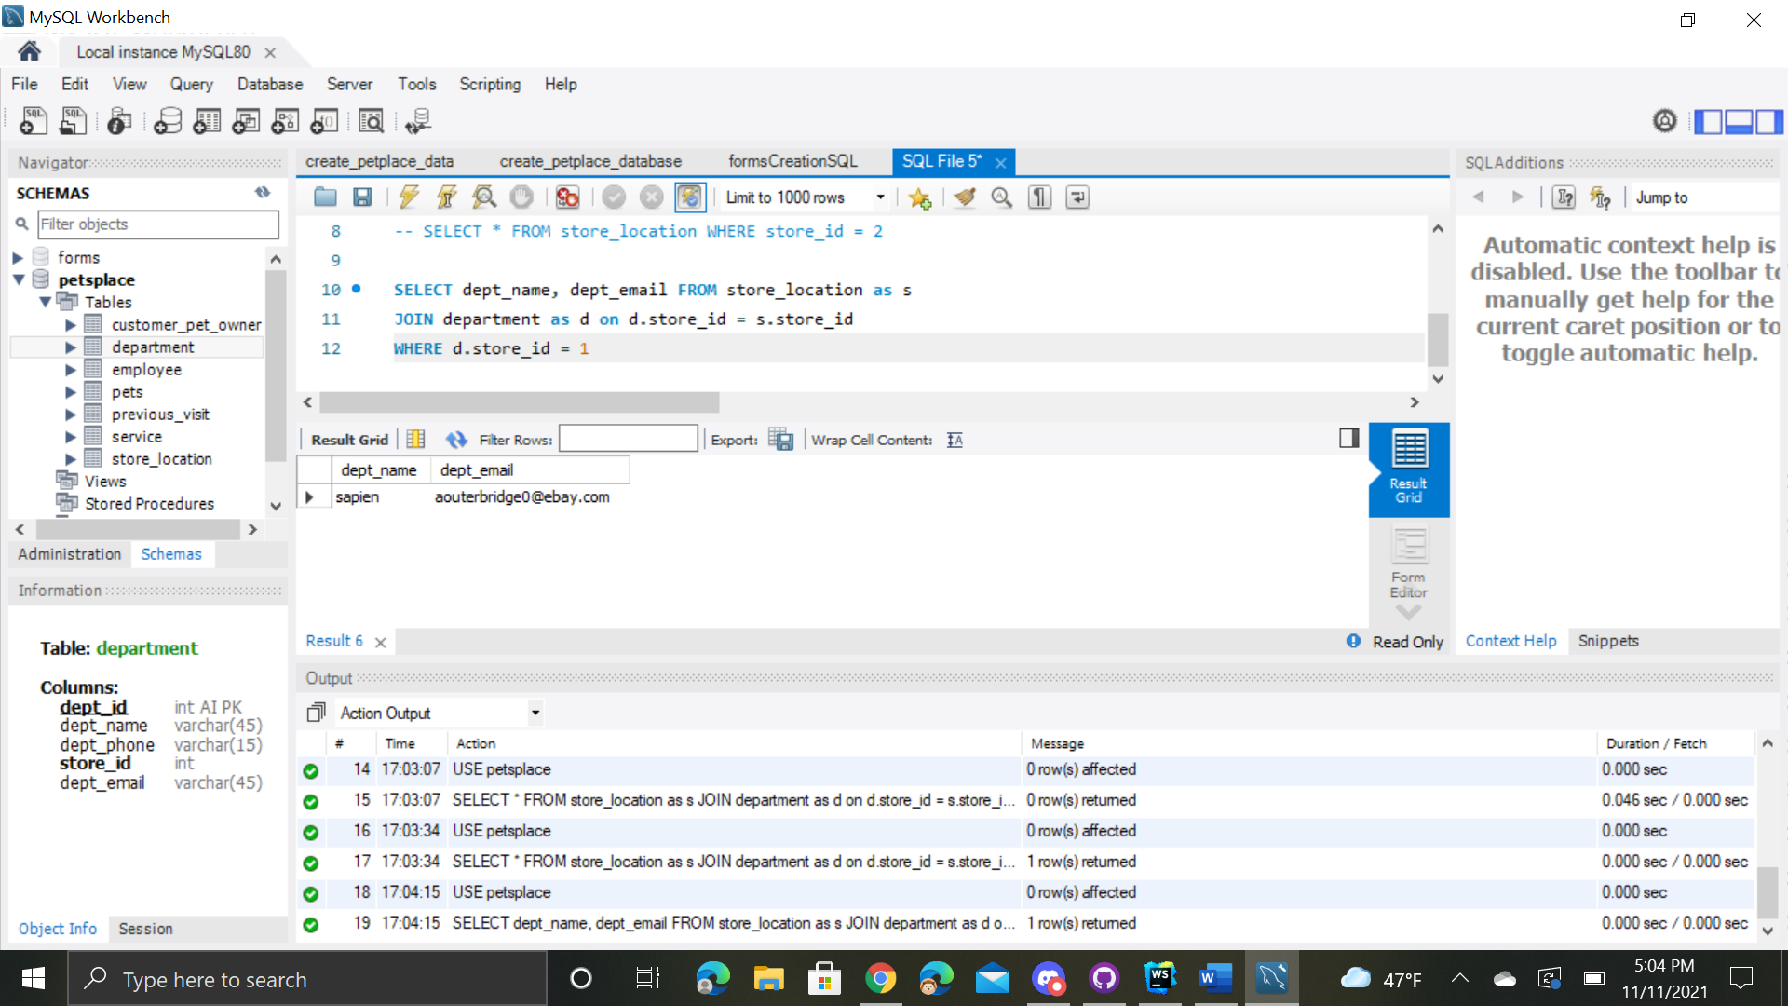



SELECT pets_id, pet_name, pet_weight FROM pets

ORDER BY pet_weight DESC

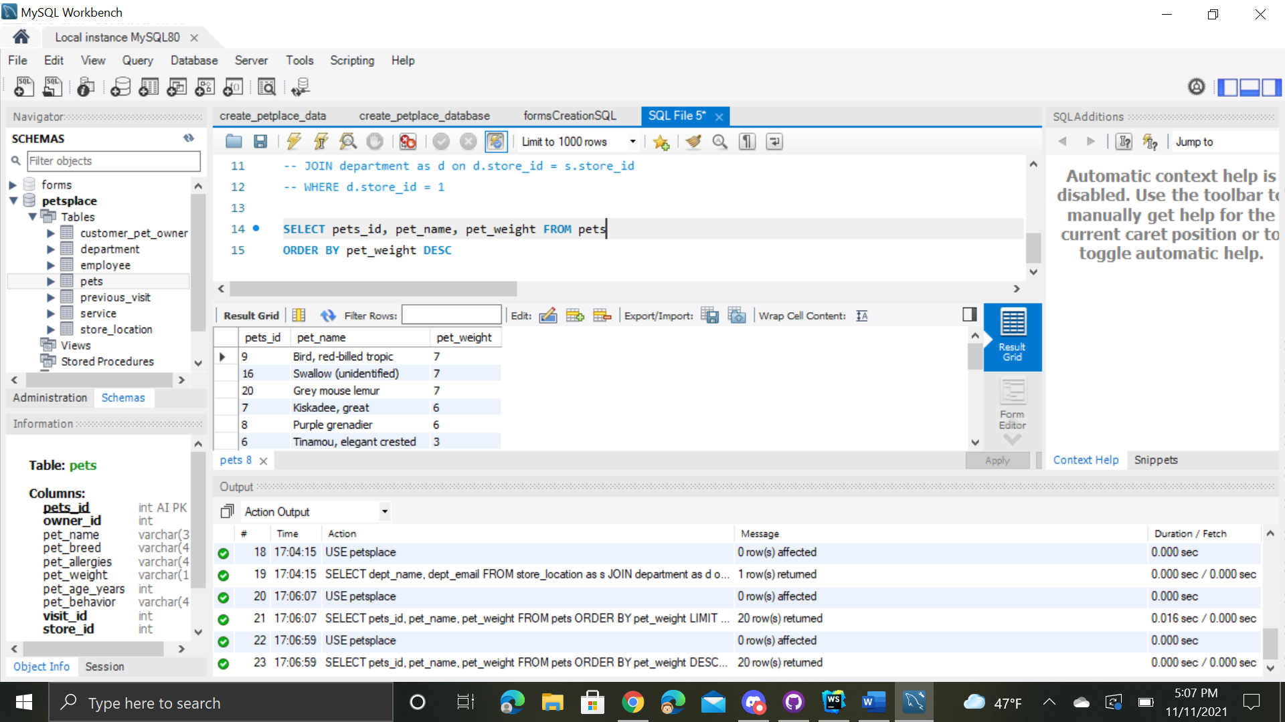



SELECT visit_id, emp_id, visit_date FROM previous_visit

ORDER BY visit_date ASC

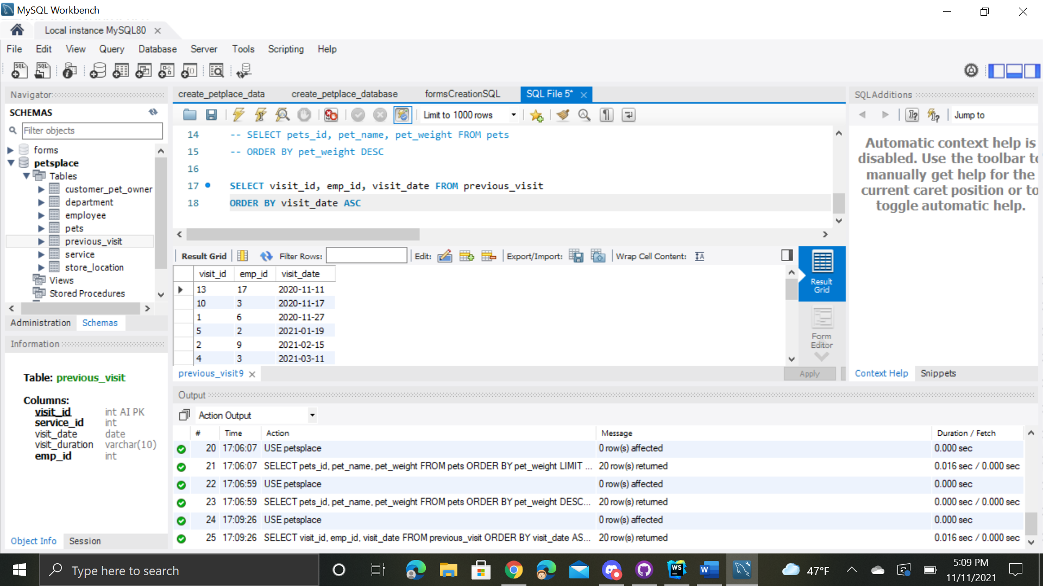



SELECT * FROM employee as e

JOIN previous_visit as p on e.emp_id = p.emp_id

WHERE store_id = 1 AND e.emp_id = 5

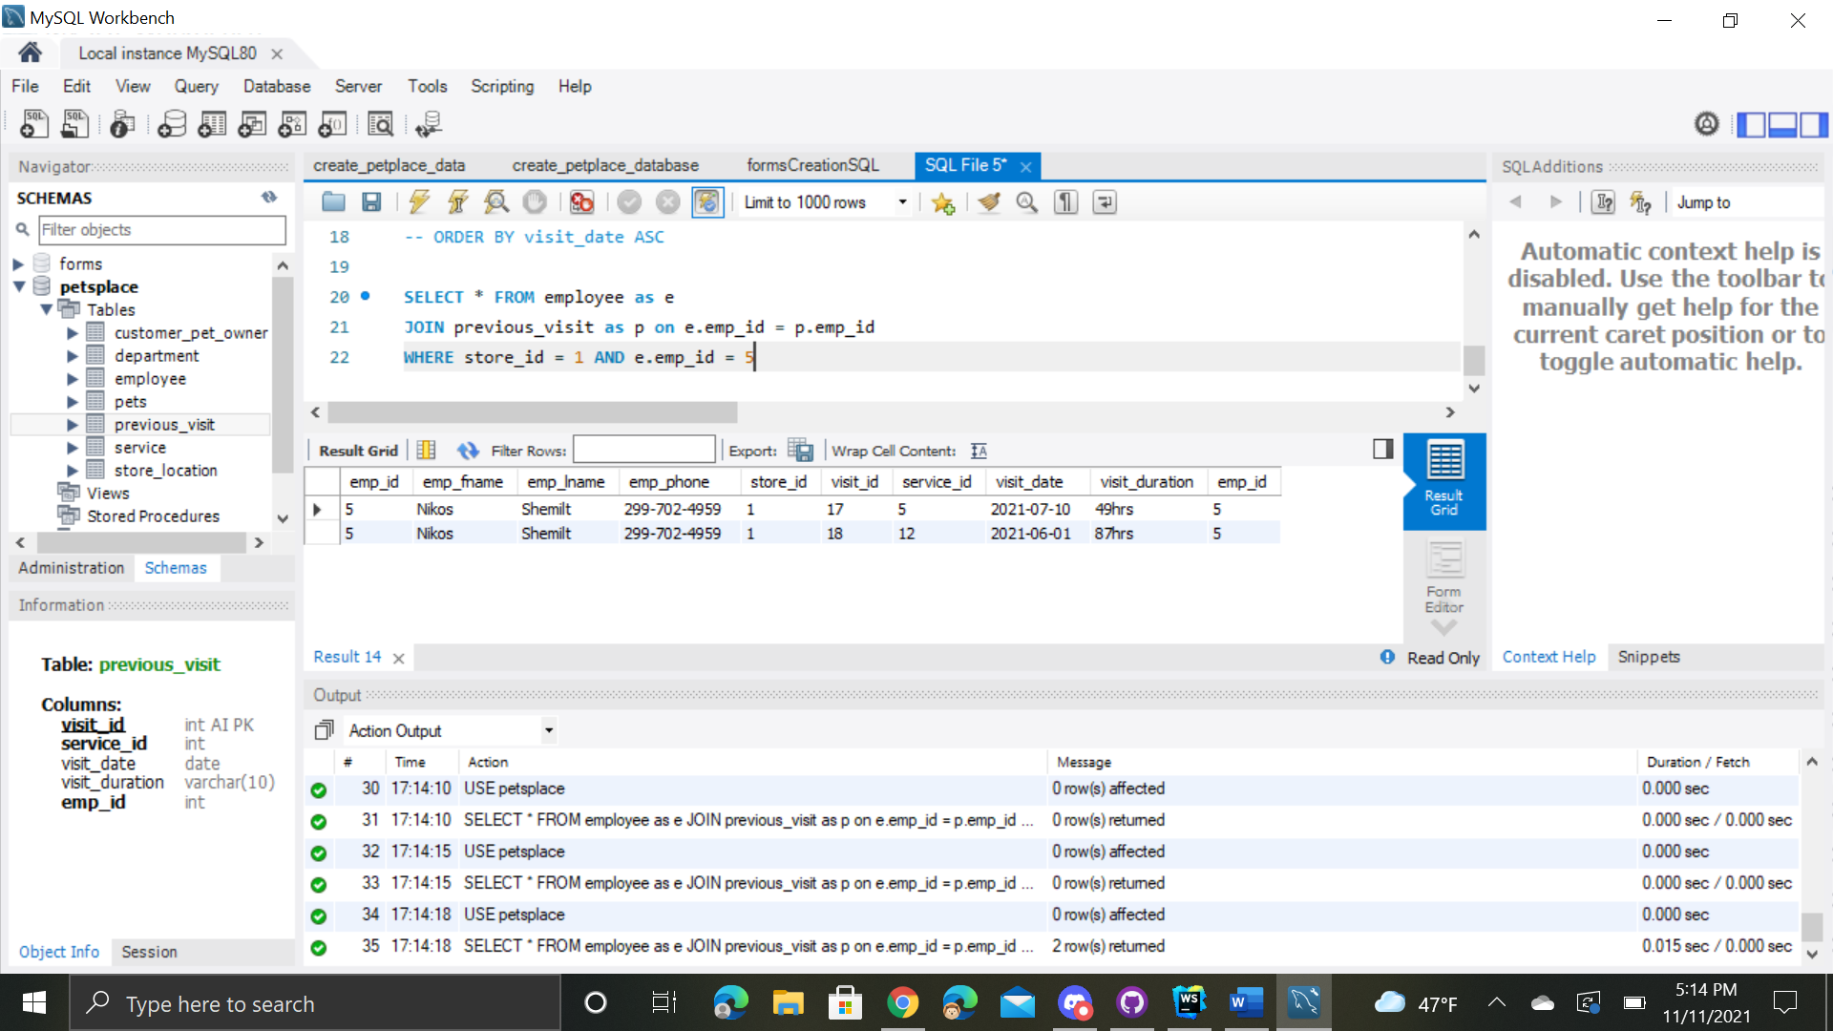



SELECT pet_age_years, pet_weight, pet_allergies FROM pets

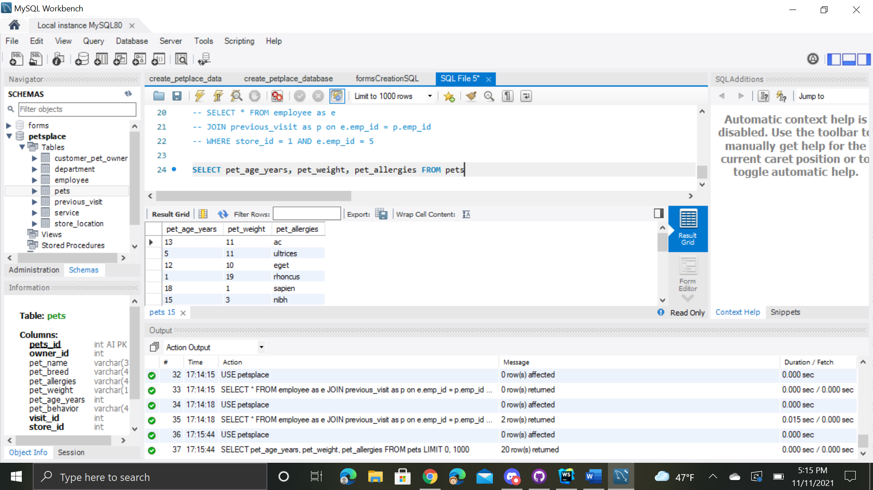



SELECT pet_age_years, pet_weight, pet_allergies FROM pets

WHERE pet_age_years = 11 and pet_weight = 11

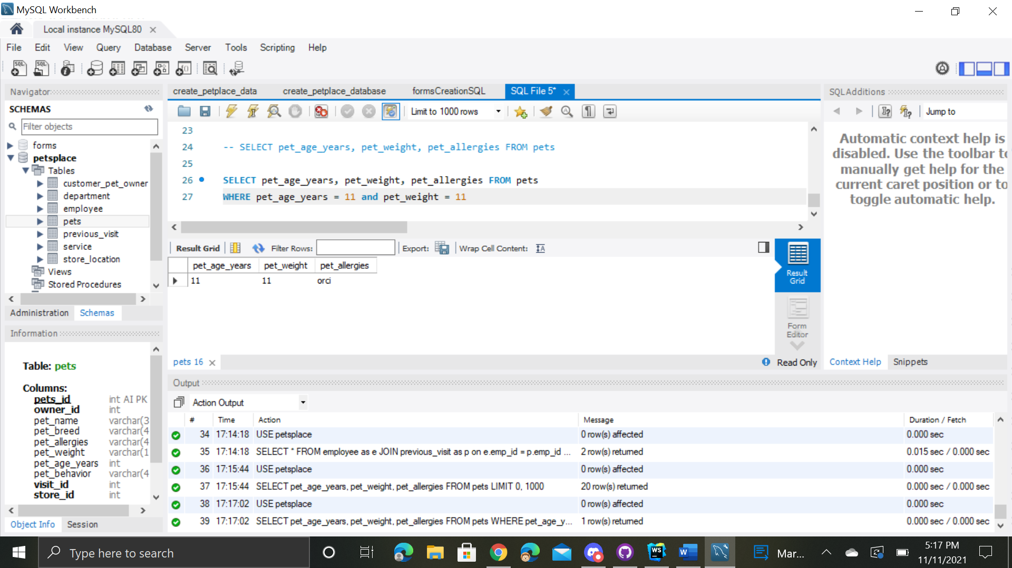



SELECT COUNT(pet_age_years), pet_name

FROM pets

GROUP BY pet_age_years

HAVING COUNT(pet_age_years) > 1;

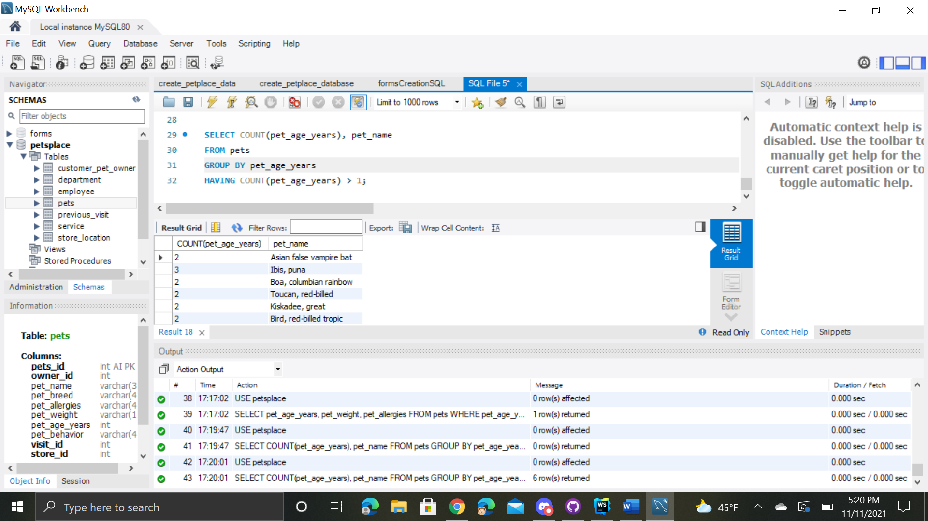



SELECT c.owner_id, pets_id, cust_fname, cust_lname, pet_name, pet_age_years

FROM customer_pet_owner as c

JOIN pets as p ON c.owner_id = p.owner_id

HAVING pet_age_years > 10

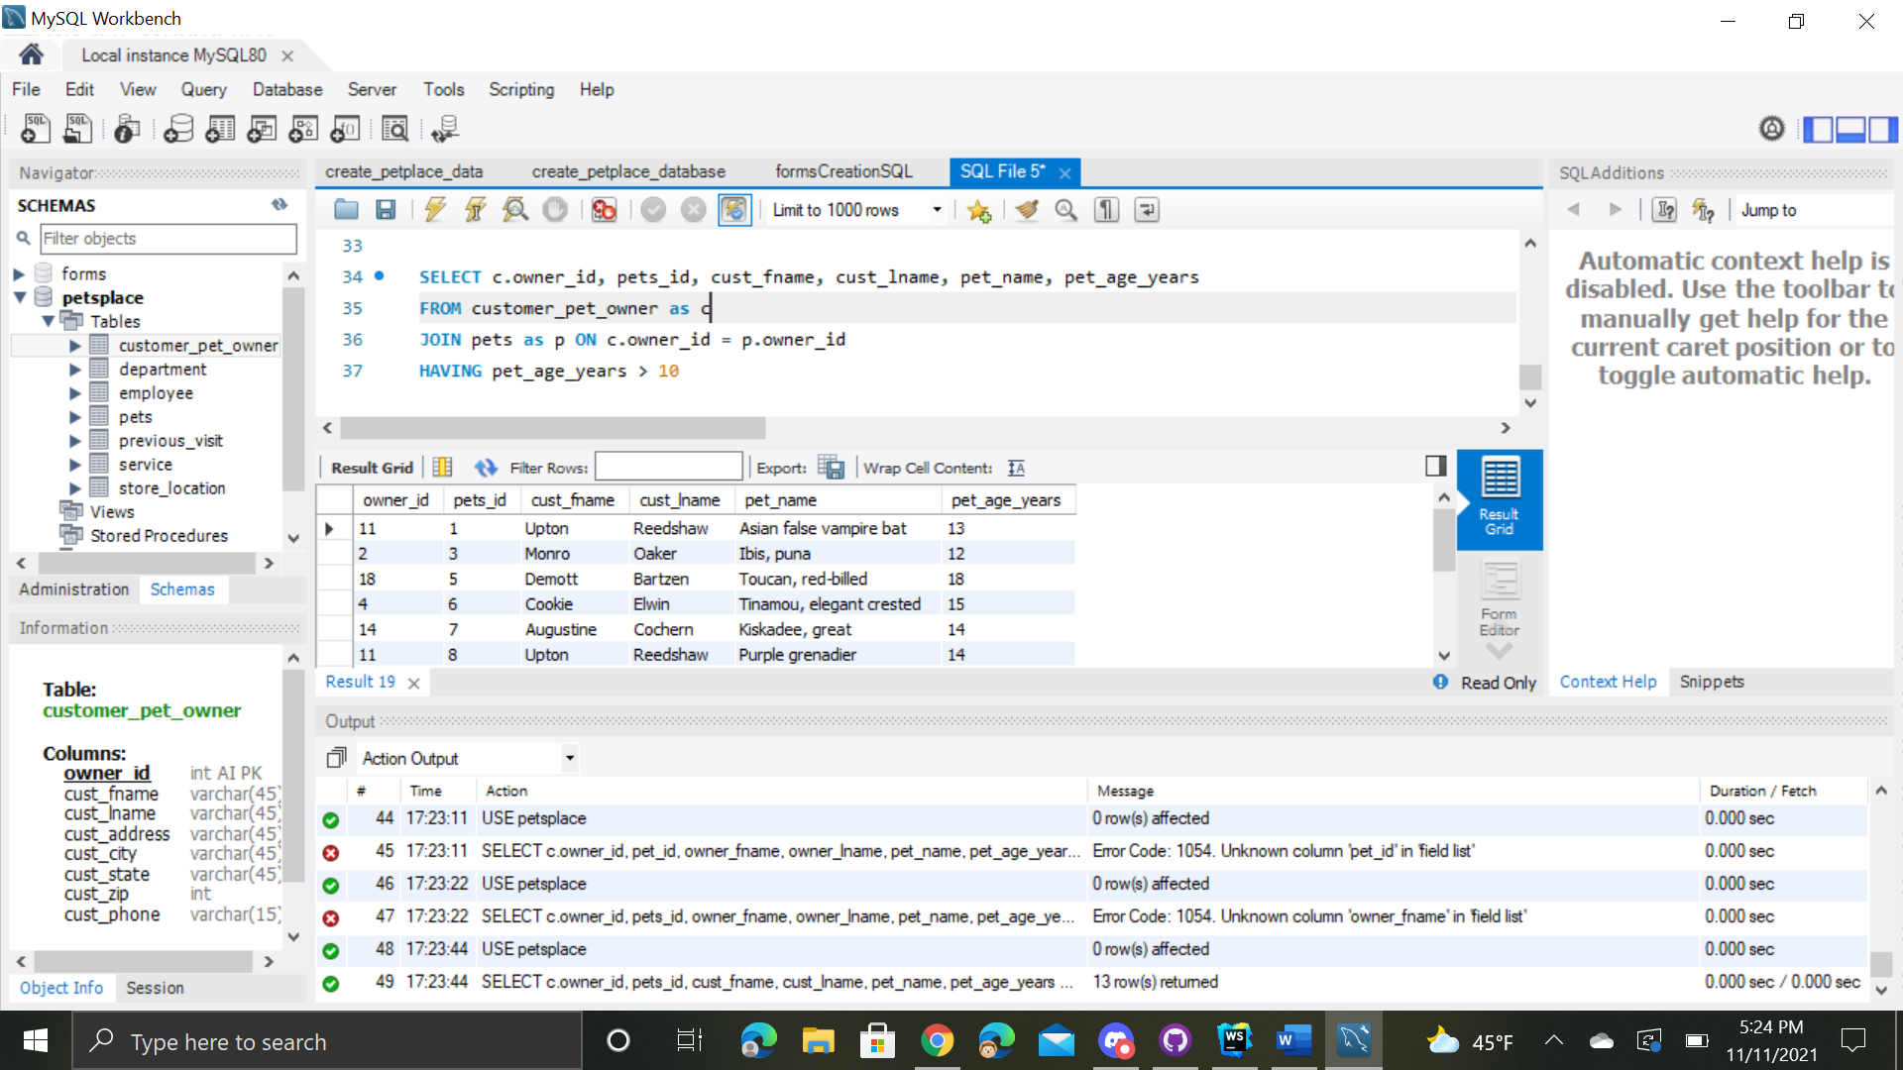



SELECT v.visit_id, visit_date, pets_id, pet_name FROM previous_visit as v

JOIN pets as p ON p.visit_id = v.visit_id

WHERE visit_date BETWEEN '2020-01-01' AND '2021-01-01'

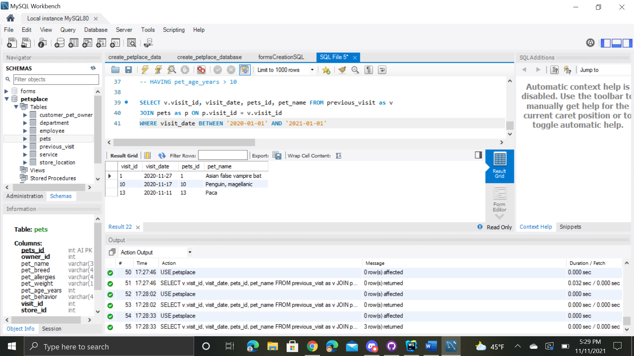



SELECT * FROM department

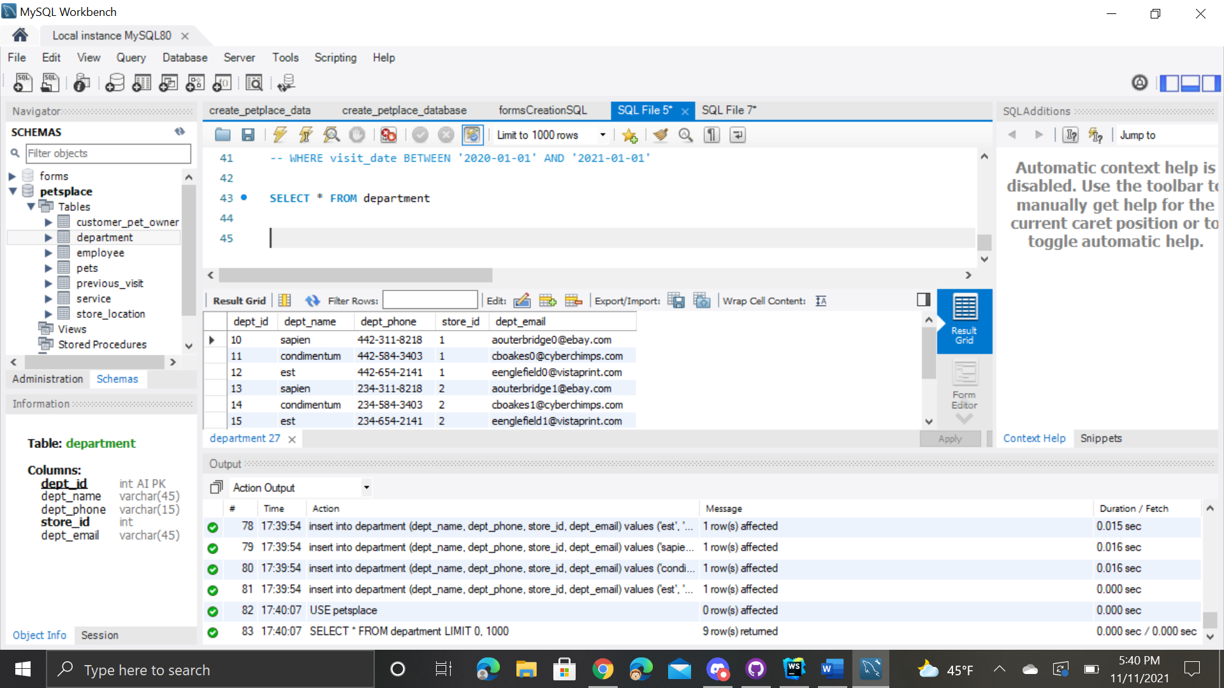



SELECT * FROM store_location

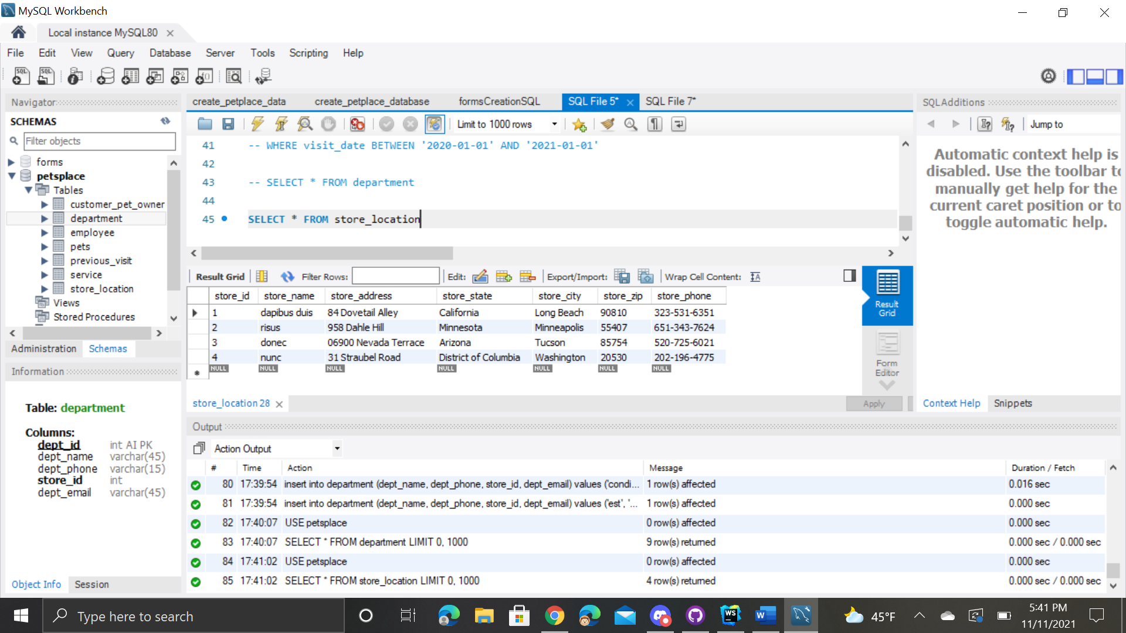



SELECT dept_name, dept_id, s.store_id, store_name, store_phone, dept_email

FROM store_location as s

JOIN department as d ON d.store_id = s.store_id

WHERE d.dept_email = 'aouterbridge0@ebay.com'

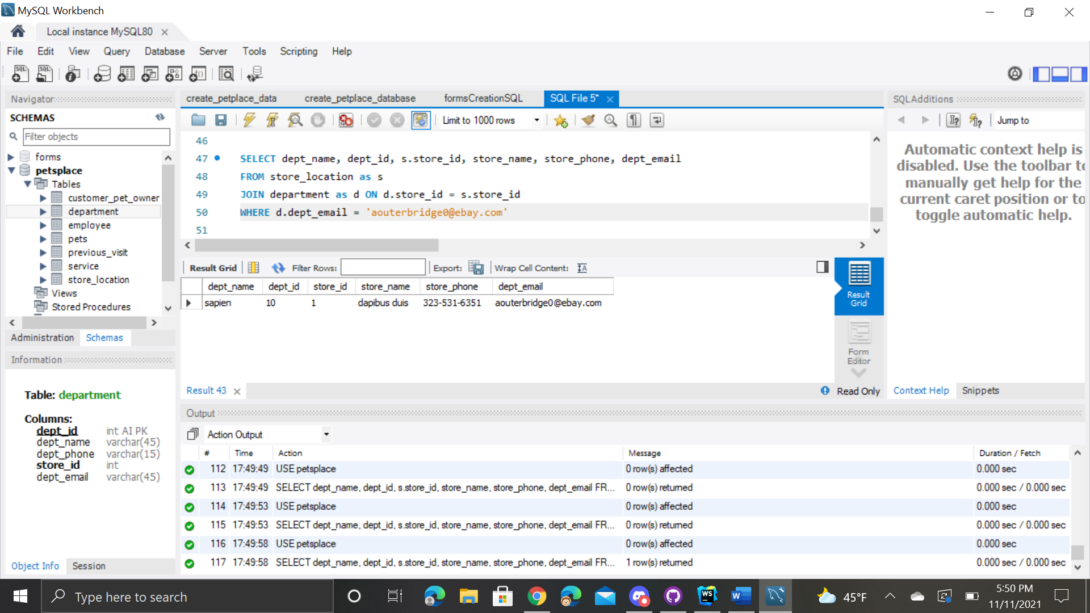



SELECT * FROM employee

WHERE emp_fname LIKE 'l%'

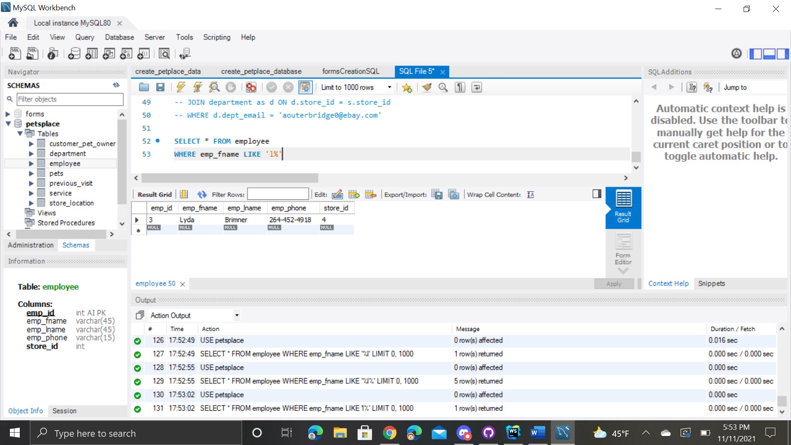



SELECT * FROM service

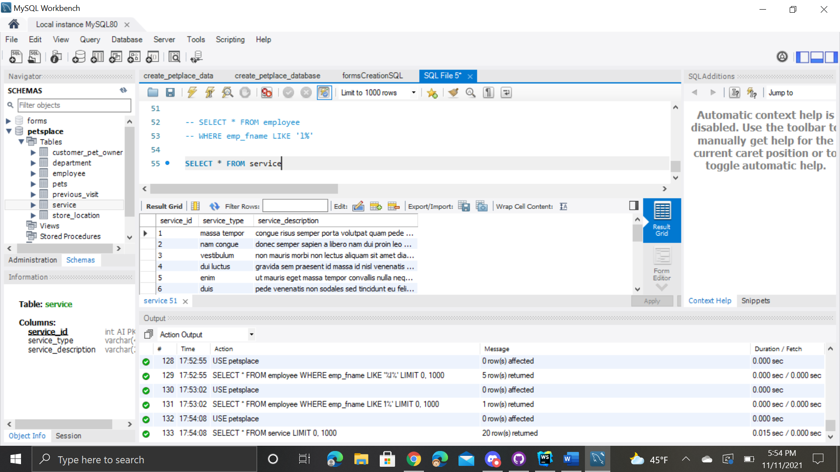



SELECT s.service_id, service_type, service_description, visit_date, visit_duration FROM service as s

JOIN previous_visit as v ON v.service_id = s.service_id

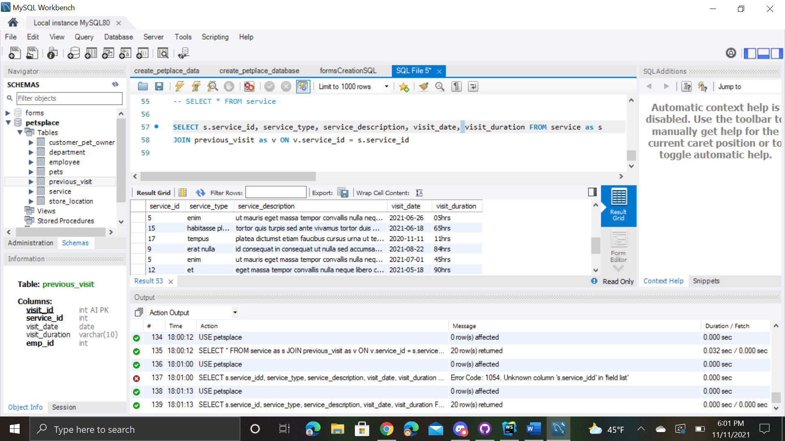



SELECT s.service_id, service_type, service_description, visit_date, visit_duration FROM service as s

JOIN previous_visit as v ON v.service_id = s.service_id

WHERE s.service_id = 17

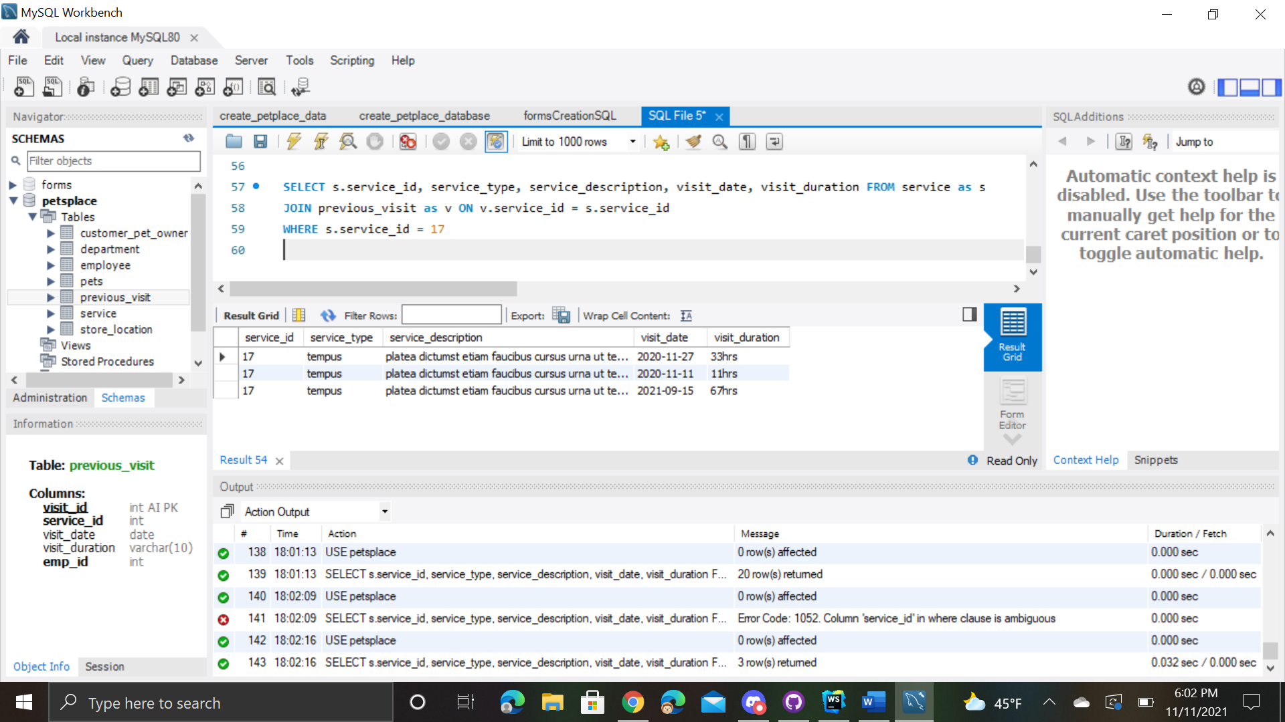



SELECT emp_id, emp_fname, emp_lname, s.store_id FROM employee as e

JOIN store_location as s ON e.store_id = s.store_id

WHERE s.store_id = 1

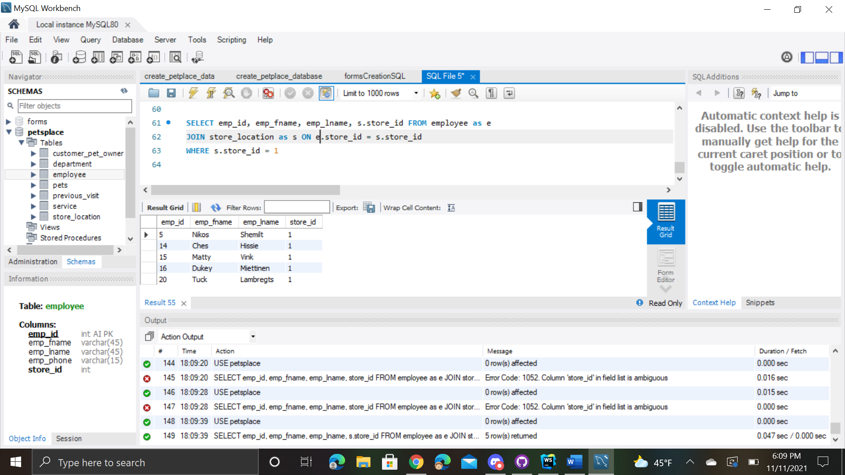



SELECT * FROM pets

WHERE pet_breed = 'sed' or pet_breed = 'hac'

